# Homework Assignment: Cryokinetic Linux Challenge

Or, Candy Cane Striper Challenge

Access this challenge through the Cryokinetic Magic. 

The terminal is sitting on top of the fishing hut. 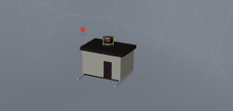

Holly Evergreen needs you to start the CandyCaneStriper process. If you run ls -l, you’ll see that the file no longer has the execute permission.

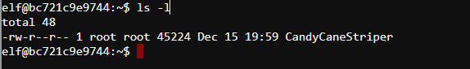

# Some Hints

Holly thinks someone has been mucking about her machine, and the chmod program fails. 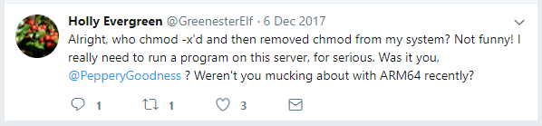

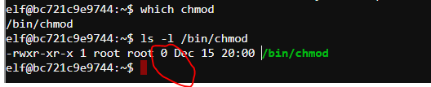

Uh-oh. The file size of the chmod application is 0 bytes. Not good.

You need to figure out how to run an executable without the execute permission, or find another way to chmod the file.

One way is to do chmod with Python. You can run Python interactively this way. 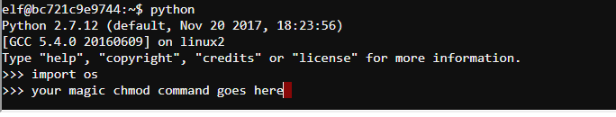

Note: you have to own the file to chmod it, and you don’t own CandyCaneStriper. If you had your own copy, though, you would own the copy.

Bonus points if you figure out a way to run the executable directly, as I didn’t…

# Hand in

1. Your solution
2. A brief description of how it works.

# Solution 1

From <https://docs.python.org/2/library/os.html>, we find the command we need is  
os.chmod(path, mode). The document lists variables, but the octal numbers from the Linux chmod command work just as well.

There is a complication, however. You cannot change the mode of a file you do not own. We can circumvent that by copying the file, however, as we will own the copy. 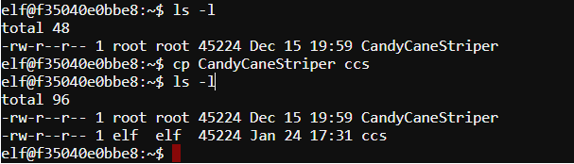

Now, we can use Python to add the execute permission. The current permissions are 644 in octal. If we add execute to user, group, and other, they will be 755.

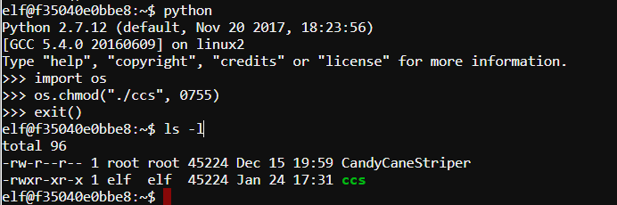

Now, just execute ./css

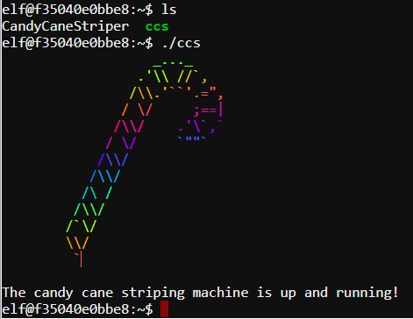

# Solution 2

If we examine CandyCaneStriper with file, we see that it is loaded by /lib64/ld-linux-x86-64.so.2.

The link <https://askubuntu.com/questions/354342/how-can-i-execute-a-file-without-execute-permissions>, shows that we can use the loader to execute the file. Note: The loader will look for CandyCaneStriper in its own directory unless we specify the path. Therefore we have to put ./CandyCaneStriper or /home/elf/CandyCaneStriper in the command.